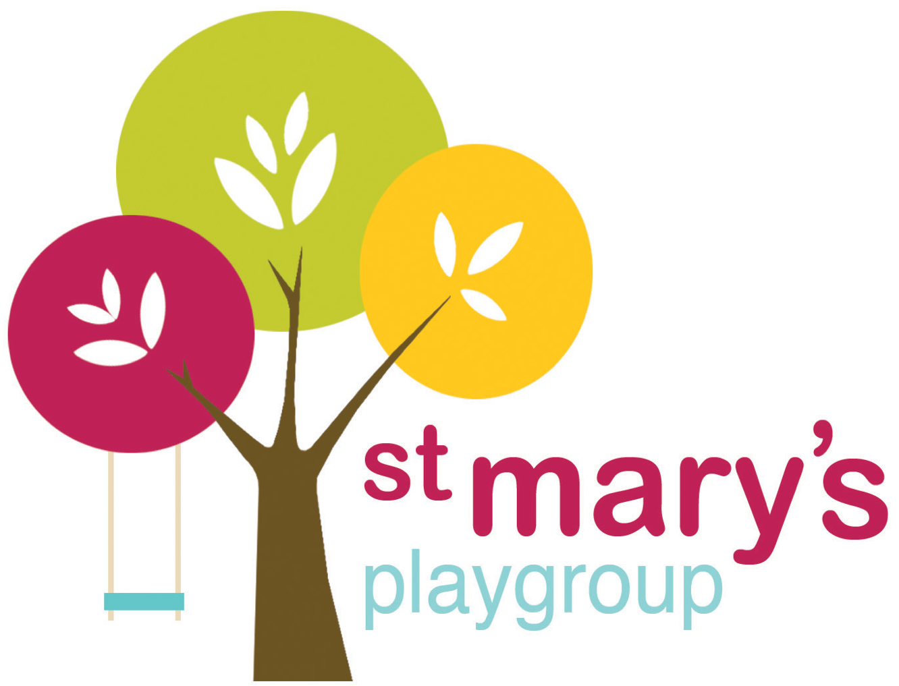

Enquiry Form

|  |  |  |  |  |  |
| --- | --- | --- | --- | --- | --- |
|  | | |  |  |  |
| Please be aware this is a session request form and whilst we will do our best to ensure we meet your needs, this will not automatically guarantee the space for these sessions. | | | | | |
| **Child’s Legal First Name(s)** | | **Child's Legal Surname** | **Child's Date of Birth** | **Child's Full Address**  **(inc Postcode)** | |
|
|  | |  |  |  | |
|  | |  |  |  |  |
| **Sessions required** (Please tick the sessions you would like to request for your child to attend) | | | | | |
| **Please note: Playgroup indoor session (9-12pm available from 2 years, all day available for 2 years 9 months):** | | | | | |
|  | **Early drop off 8.30am** | **Morning session**  **9-12pm** | **Lunch Club 12-1pm** | **Afternoon session**  **1-3pm** | **Late drop off 3-3.30** |
| **Monday** |  |  |  |  |  |
| **Tuesday (Preschool Only)** |  |  |  |  |  |
| **Wednesday**  **(Non-preschool only)** | Not available |  | Not available | Not available | Not available |
| **Thursday** |  |  |  |  |  |
| **Friday** |  |  |  | Not available | Not available |
| **Forest School session (available from 3 years+):** | | |  |  |  |
|  | | **Early drop off 8.30am** | **Morning session**  **9-12pm** | **Lunch Club**  **12-1pm** | **Afternoon session** |
| **Wednesday** | |  |  |  | Currently unavailable |
| **Thursday** | |  |  |  | Currently unavailable |

|  |
| --- |
| **Requested/Preferred Start date:** |
|  |

|  |  |
| --- | --- |
| **Parent Name:** |  |
| **Contact Number:** |  |
| **Email address:** |  |

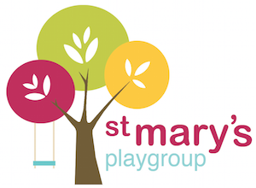

Thank you for your interest in registering your child with us at St Mary’s Playgroup!

St Mary’s playgroup is a well-established Early Years setting and has now been running for 50 years! We operate from Christ Church hall and offer a variety of flexible term-time sessions as well as now offering Forest School sessions on the grounds at Holford House (on the edge of town). Our morning sessions on a Monday, Wednesday, Thursday and Friday are available from the age of 2 years with longer ‘all day’ sessions from 2 years 9 months. We also offer an early drop off from 8:30am and a preschool only session on a Tuesday.

Our Forest School sessions currently run on a Wednesday and Thursday from 9am-12pm with the options of early bird drop offs (8.30am) and lunch club (from 12-1pm). These session are available from 3 years+ and are an incredible opportunity for children to learn outdoors. If you’d like to find out more about this or come and visit our site please let us know when you email in your enquiry form so we can arrange this with you.

On a Monday morning from 9-11 we hold our ‘seedlings’ baby and toddler group at the front of the church and this session is ran by a member of our team which makes it a fantastic ‘starting point’ for children getting used to the surroundings and staff in a very relaxed and informal way. We welcome all families to come along for activities, crafts and snacks with their children and this can also be a good time to pop through with your child near to when they are starting to come and have a play.

To secure a place for your child(ren), please fill in the enquiry form and either drop it into us or email it to:

[stmarysplaygroupleader@hotmail.com](mailto:stmarysplaygroupleader@hotmail.com)

Our Manager Kelly will be in touch to discuss availability and to offer you the chance to visit and see what we do and who we are. Should you then wish to go ahead and register your child with us there is a non-refundable £50 registration fee.

We look forward to hearing from you and hope to welcome you into the St Mary’s Playgroup family soon!

The St Mary’s Playgroup Team